Abstract: The world relies heavily on the Internet, and every organization uses web applications extensively for information sharing, business purposes such as online sales, money transfer, etc., and Exchange services. Nowadays, providing security for web applications is the greatest challenge in the corporate world because web applications will be the main way for their daily business and if the web application is affected, then daily business and reputation will be affected. As many organizations have been using the web application service to share or store sensitive information about their clients and assets. So, Web Applications are inclined to security attacks and new security vulnerabilities have grown in the last two decades in a web application and have become an important target for attackers. So, it is very vital to secure a web application. The vulnerabilities in web applications will incur due to the security misconfigurations, programming mistakes, improper usage of security measures, etc. So, vulnerability assessment and pen testing will help to figure out the different vulnerabilities present in web applications. The websites are also using to deliver the critical services to its customers so it must run every time without any interception, to do this VAPT will play a crucial role. This paper reviews about vulnerability assessment and pretesting steps and types, website vulnerabilities like SQL Injection, Cross-Site scripting, file inclusion, cross-site request forgery, and broken authentication with types and remediations and also discuss how the effect of these vulnerabilities on a web application.
Addressing Web Application Security Issues and Vulnerabilities Assessment Pen Testing
Matthi Naveen*, Dr. Pragnyaban Mishra

Keywords: Cross-Site scripting, cross-site request forgery, file inclusion, penetrating testing, steps in VAPT, SQL Injection, vulnerability assessment, VAPT Types, Types of XSS, Types of SQL injection.

INTRODUCTION
The majority of IT companies and many organizations are using web applications for their business use or information sharing. Due to the increase, the usage of internet the accessing on web applications from anywhere made easy and has become essential in the daily lives of people, business and all organizations. Web application advancements give a promising system of coordinating many useful segments over the web and so empower people and associations to cooperate the utilizing of application program interface along with enormous topographical separations. Billions of people everywhere throughout the world use web application advancements to exchange data, do money related exchanges, and have fun and do communication between them
Web application grew tremendously, and it has benefits and challenges like security associated and very important to address it. Security flaws in a web application will arise due to flaws in designing, and implementation which will be a threat to business. A web application is an important target for cyber-criminals due to their public access and increasingly used to deliver critical services to a user. Most of the websites will use a database as backend which helps to manage data easily and this data will also contain sensitive information. sensitive data would be infringed, resulting in severe economic damages, ethical and legal implications due to compromisation of web application
The web application will be developed and deployed on the complex infrastructure and different development technologies so there will be an inconsistency due to a huge range of technologies and secure development can also be error-prone and can lead to vulnerabilities. Web Application Security Consortium, about 49% of the web applications being reviewed contain vulnerabilities of high-risk level and more than 13% of the websites can be compromised completely automatically [17]. A recent report [18] reveals that over 80% of the websites on the Internet have had at least one serious vulnerability. Different vulnerabilities will be available in the web application and these vulnerabilities will change based on the front end and backend technologies used by a web application. vulnerability is a security weakness or a loophole that will take advantage of the attacker or malicious users to gain unauthorized access. Day by day the web application usage has increased, and the new vulnerabilities are also increasing. The vulnerabilities in web applications will incur due to the security misconfigurations, programming mistakes, improper usage of security measures, etc.. The websites are also using to deliver the critical services to its customers so it must run every time without any interception, to do this VAPT will play a crucial role to find out the security vulnerabilities in web application and address them to protect web applications.
This paper is presented as follows chapter one is an introduction, in chapter two we discussed the basics of web applications, chapter three is discussed about the VAPT steps and types, chapter four is discussed about the web application vulnerabilities introduction and discussed vulnerabilities, types and remediation and the final chapter is a conclusion.

INTRODUCTION TO WEB APPLICATIONS
The Web Application Security Consortium (WASC) defines a web application as "a software application, executed by a web server, which response to dynamic (or) static web page requests over HTTP" [3]. Websites will consist of style sheets, HTML pages, images, client-side scripts, etc. that will be available in a web application server.
Web applications will use the Internet Infrastructure for exchange of information and services between the organization and end-user, for a good introduction to the web application from the penetration tester's perspective; the information can be gathered from Web Consortium [3].
Now a day’s web application will consist of n-tiered architecture. Where client will be a browser, an application server is where the code is deployed, and a back end will be a database to manage and store data and Figure 1 represents the communication flow of web application requests and response and There may be a firewall, proxy servers, WAF's in between a web server and browser for added security.

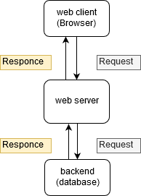
Fig 1. Web Application Environment.

OVERVIEW OF VAPT

Steps of VAPT
Types of SQL Injection
- Pre-Engagement Interactions or Scoping
In this phase, the pen testing team will discuss in detail the scope of the assessment, objectives, legal implications, goals and organizational assets available will be disused in detail. best-suitable penetration testing technique will be chosen based on the organization's threats, culture, equipment available. Types of organization. the legal issues will also be addressed for avoiding future inconvenience. In this process, organizational assets will have to categorize based on assets in scope (assets on which penetration testing must do) and assets out of scope (not included in penetration testing) based on all organizational assets.
- Reconnaissance
Reconnaissance is also known as Open Source Intelligence gathering. This step will help to gather all required information and a potential target for exploit required about client organization. The pen tester will have different degrees of organizational information collected during the first phase and by using this information tester may get critical information to locate hidden vulnerabilities and loopholes in the system.
The pen testers will use the different Reconnaissance techniques which include searching in different search engines, Domain name searches, social engineering, searching for records, internal Foot printing for an email discussion, usernames, and social networks accounts, tailgating, etc.
- Threat Modeling & Vulnerability Identification
This phase is also known as pre-attack and testers will think like attackers and will scan the system as deep as they can and identifies different targets and also maps organizational attack vector based on threats, here targets will be business assets like employees data, customer data, technical data, and threats will be internal threats like employees, vendors, distributors, board members, stakeholders, etc. and external threats like Network devices facing external network, Applications belongs to organization, Network Traffic, attackers, etc.
The internal threats will be controllable by the organization, but external threats will be out of control. In this phase, the pen testers will use different automated tools and manual testing tools to scan all the organization in-scope assets. After completing the information gained will be the different vulnerabilities in the servers, web application and all the in-scope assets.
- Exploitation
In the exploitation phase, the testers will use the different exploits based on all potential vulnerabilities and entry points gathered in the Threat Modeling & Vulnerability Identification Phase. The main aim of the pen tester is to verify how far they can get access to the system and find high-value targets without being avoid detected.
The pen tester will exploit the system based on scope defined and the penetration testers will use the standard exploits like Web Application exploits, Network exploits, Memory-based exploits, Wi-Fi exploits and will also use Physical Attacks and Social engineering attacks. In this phase, the system has to exploit after developing the threat vector and attack plan based on vulnerabilities to get access to the system and sometimes the system can have the secure network which has DMZ, firewall, honey pots, and honey well so that the pen tester should use different evacuation techniques to bypass these security devices.
- Post-Exploitation
In this phase, the attacker will try to collect and store all evidence all methods to get gain access. The pen tester should take all the pieces of evidence required to generate the report and after collecting the evidence the team should clean up the system to revert the activities done during the exploitation phase.
The cleanup activities should be performed to Remove any installed malicious applications, scripts, temporary files, restoring system and network settings, removing any types of malware codes injected, etc. and should make sure that all installed backdoors or rootkits should be removed, and it should make sure that a system configuration is restored to its original state at pre-engagement state. Any credentials that have been changed should be restored, and any additional usernames created should be removed.
- Reporting
This report is the best method to convey the findings of a pen test. This report will address the managers and the technical team. From the manager's perspective, they will have information like different vulnerabilities and their Business impact on the system. In the technical team perspective, they will have information like different vulnerabilities with its remediation.
The pen test report will begin with a summary that outlines all organizational business-related penetration test plans, defining outcomes by risk ranking. This section should be concise, and it could be the client's most important piece of decision-making and the business team can decide what to correct and what problems pose risk. The remaining part is a technical detail, which will be descriptive, specific and generic or ambiguous statements that help the technical team to resolve security issues.
- Resolution & Re-Testing
In this phase, the technical team will resolve the issues and they will get the assistant from VAPT team to solve the issues if they have any problem and Once vulnerabilities have been remediated, the client has to retest their systems to make sure that fixes were successful and whether the new vulnerability was created as a result of remediation or not. And the vulnerability assessment and penetration testing should also be conducted whenever there will be any modification in the system for finding new vulnerabilities.

Types of VAPT
- Black box pen testing
Black box testing is carried out without the knowledge of evaluating infrastructure so pen tester will act as a real-world hacker. The pen tester team will scan the entire infrastructure as an outsider to find vulnerabilities. Black-box penetration testing is based on a detailed review of all available resources in a system. A black-box penetration tester should know both automated and manual testing methodologies. Generally, this is the best approach because it helps pen testing team to think out of the box and do testing in all levels according to their realistic knowledge and ability and they will also use all the techniques and methodologies available for them by simulating the level of persistence, knowledge, and ability that a real-world hacker can do.
- White box pen testing
Pen testers will have full knowledge of the infrastructure and its internal design and working and known as clear box testing. The penetration tester seeks to obtain as much input to get more knowledge and better understand the system so that they can further expand their penetration tests. The main challenge with white-box testing is to analyze a large amount of data and extract data to find possible vulnerability points, making it the most time-consuming. In white-box testing, we can find logical errors, a syntax error or typographical errors, design flaws, human errors, etc. While performing the white box testing the pen testers has full access to the system for performing audits on the high-risk area.
- Grey box pen testing
Grey box pen testing is also known as translucent testing, more efficient but time-consuming because sometimes testers will test every single input path or field. the tester will have limited information on the internal working of the system and source code. The grey box testing will not be useful during the development phase because in the end-user perspective grey box pen testing is carried out that aims to analyze the front-end functionality and the internal workings of the system. Grey box pen testing will have benefits of a white and black box.

WEB APPLICATION VULNERABILITY
Vulnerability is a weakness in the application which can be a design flaw or implementation bug that allows an attacker to cause harm to users of an application [15]. Formally, vulnerability is defined as “The existence of a weakness, design, or implementation error that can lead to an unexpected, undesirable event compromising the security of the computer system, network, application, or protocol involved” [5].
In many web applications, the Vulnerabilities will arise due to poor design strategies, configuration mismanagement, the complexity of software, accepting unsanitized input from the user, weak authentication management and features misuse. The impact of vulnerabilities depends on the severity of a vulnerability. Vulnerability assessment and pen testing should be done periodically for identifying, classifying, remediating and mitigating vulnerabilities that arise in web applications to secure the web application. the testing guidelines for web applications will be given by the organization like OWASP, OSSTMM, ISSAF, Microsoft, etc. The commonly used standard OWASP and classification (TOP 10) of a web application vulnerability is given in the below table and OWASP will also release the testing guidelines with a checklist.
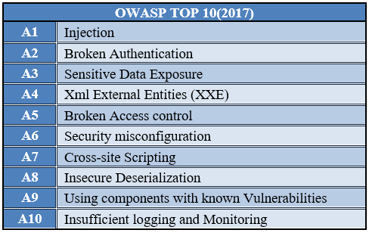
Fig 3: OWASP (2017) Top Ten Web Application Security Risks
In 2018, around 70 types of weaknesses in web applications are found. As always, Cross-Site Scripting (XSS) vulnerabilities are present in many web applications [1]. Four out of five web applications contained configuration errors such as default settings, standard passwords, error reporting, full path disclosure, and other information leaks that might have value for potential intruders [10]. More applications are vulnerable to information exposure. Access to configuration and debug information, source code, session identifiers, and other sensitive information is possible in 79 percent of web applications [10]. This is concerning when compared to past years such as 2016 (60%) and 2017 (70%).

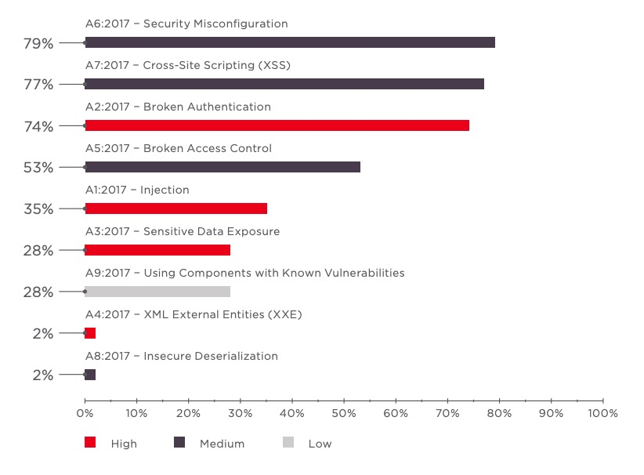
Fig 2:percentage of web application effected based on OWASP TOP 10 Vunlerabilites[10]

The percentage of an application based on vulnerabilities severity (high, medium, low). in 4 years is shown
in below image and the major of web applications are affected with a high level of vulnerabilities only

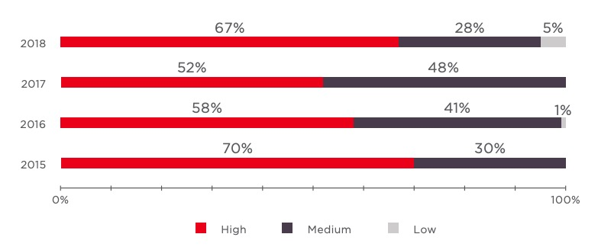

Fig 3: Percentage of Web Application Affected yearly

The different high-level vulnerabilities are disused below:

SQL injection
The attacker will use dynamic SQL statements in the SQL Injection Attack to comment on the components of the declaration or to add a statement that will always be conditionally true. The attacker uses the design faults in a web application to exploit SQL statements by injecting malicious SQL code and SQL Injection is also one of the injection attacks [7].
Usually, SQL injection happens when input is taken from a user, such as a username, password fields, id parameters, etc. The attacker will inject the SQL statements which will directly be executed by SQL parser and attacker will try to control a database server to retrieve data and can also use for bypassing authentication schema.
SQL injection vulnerability will be found in applications that are implemented using the SQL query language, using back end databases like MySQL, Oracle, SQL Server, or others. SQLI is a common attack vector by this means the malicious users can pass the malicious payloads to SQL parsers to manipulate or access confidential, sensitive information like customer information, personal data, etc. stored in a database. SQL Injection attack is the most dangerous Vulnerabilities in web applications.
An attacker must first discover vulnerable user inputs fields and parameters in the web application to do an attack and user input fields will be used to pass payload for performing SQL Injection attack. SQL injection also termed SQLI. Input content crafted by the attacker for injection is called malicious payload and it is the main component of the attack. After that malicious user tries to change the parameters with malicious payloads than database executes malicious SQL commands and gives an output with database content relevant to the payload.
The different types of SQL Injection
- In-band SQL Injection
The attacker utilizes the same communication channel to launch their attack and collect outcomes. The simplicity and effectiveness of In-band SQLI make it one of the most popular SQLI attacks [11]. This technique has two sub-variations.
- Error Based SQL Injection: The malicious user tries to pass the database commenting statements in the request which will generate the database related error message in the response’s then malicious user will pass the further commands based on the error message generated. By using error messages, a malicious user can gain information like types of database using, a version that can be used for further attack.
- Union Based SQL Injection: The malicious user will try to fuse different UNION based SQL command with select statements which will be passed to the database. The database will execute the query and response based on injected payload.
- Inferential SQL Injection
The attacker sends payloads to the database server and observes the server's response and behavior to more information about database structure because in a blind SQLI attacker cannot see or get much information in response [11]. This injection will depend on the change and behavior in response from a web application server, to do these types of attacks consume a lot of time because the attacker has to retrieve the character by character but can be just as damaging. The following can be types of blind SQL injection:
- Boolean based SQL Injection: The attacker will construct Boolean based payloads and sends them to the database through SQL statements in such a way that the response from the database will change based on the result of the condition. Based on the result, the response data will change. By observing the change in response, the attacker can retrieve information from the database.
- Time-based SQL Injection: In time-based SQL injection techniques, the attacker will try to inject payloads which will make a database to give a response with time delay based on payload. Here the attacker can use SQL methods like SLEEP (), BENCHMARK (), WAITFORDELAY (), etc. which have specific special DBMS function (or) can use heavy query as payloads which will help to generate the time delays. Based on the time delay in the response, the attacker can guess information.
- Out of Band SQLInjection
Out - of-band SQLi will be used only if the attacker is unable to start the attack and retrieve the data using the same channel, or if a server is unstable to do perform SQL Injection. In this method, the attacker will rely on the server's ability to generate DNS or HTTP requests which help to transfer the data gained from SQL Injection [11]. The out-of-band SQL injection will only possible if and only if the relevant features are enabled and have access has database server for end-user.
The best Preventive measures for SQL Injection are:
- The prepared statements with parameterized queries or stored procedures can also be used which is harder to implement but a much effective way to prevent the SQL injection.
- The input parameters should properly escape the special characters and should have to verify that the input provided is in a pre-defined format or not.
- while storing in the database Encrypt or hash the confidential data instead of storing in plaintext which will give a further level of protection if the attacker successfully enters the system.
- Restrict the rights and privileges of the database by reducing the user's capabilities to the bare minimum. This will restrict intruders or attackers if they succeed in gaining access.
- the common database error messages should not be displayed directly to end-user instead the custom error messages should be displayed for end-user
- By using the WAF (Web Application Firewall) for web applications with database access and confidential data helps to protect from malicious payload injection attempts by identifying and blocking malicious payloads based on firewall configuration rules.

Cross-Site Scripting
Cross-site Scripting is a client-side injection attack where malicious users will execute the scripts in the victim browser by injecting malicious payload in the legitimate web application [4x]. Every time the users accessing the links that are injected with the malicious script then the real attack will happen.
The web application has become a great way to execute a malicious script to the user browser. Usually, the attacker will target the web application with forums, message boards, and web pages that allow comments, search boxes, input fields will be targeted by attackers to inject malicious payload for performing cross-site scripting [2]. At first, the attacker tries to find web pages vulnerable to XSS and tries to inject the malicious payload in the vulnerable pages whenever the user tries to load that page then the malicious payload will be executed at victim browser and JavaScript will access the cookies and sends to an attacker and by using these cookies the attacker can impersonate the victim by using session hijacking attack as shown in below image.

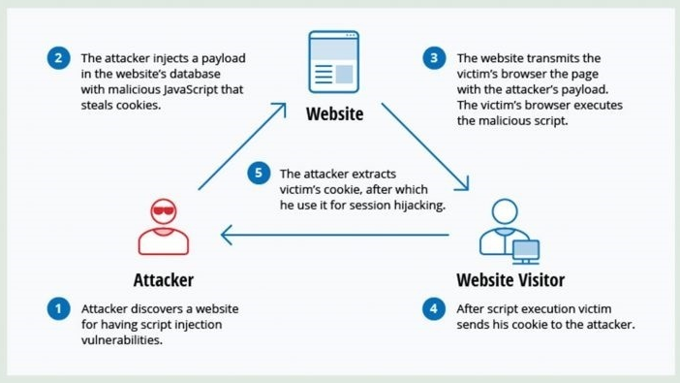
Fig 4: Demonstration of an XSS attack.
By using the XSS the attacker may damage the website, can inject malicious scripts to change the content, or may even redirect to other websites with malicious content. Vulnerability is regarded to have less impact than SQL injection. At first, the consequences of the ability to run JavaScript on a web page might not seem severe. Because most modern web browsers run java scripts in a controlled environment and have limited access to the systems files. But if JavaScript part of malicious content, also dangerous as Malicious JavaScript can also access all objects that the remaining web pages can access. This includes accessing the User cookies that often used to store data related to the session. If a malicious user succeeds in obtaining the cookies of a user then the malicious user will access the user accounts to do a malicious action on behalf of the user and can access the sensitive information and JavaScript can use the XMLHttpRequest object to send arbitrary HTTP requests to destinations by using HTML5 APIs in modern browsers which can be used for accessing files from user file system, geolocation, webcam, and microphone. Most of these APIs need granting permission from the user to execute in the browser, but the malicious user may use social engineering to address that restriction.
Types of Cross-site Scripting
- Reflected Cross-site scripting:
In Reflected cross-site scripting, the attacker will inject the malicious script in the request and send the request then the web application server will process the request and will send the response to the client with injected payload in an unsafe way which will lead to the execution of script code at client-side browser. Reflected XSS is also known as non-persistent or TYPE II XSS [8]. here script injected by a malicious user will be executed on the same place or page where injected so in generally malicious user will be delivered XSS to the victim by the other means like email messages with malicious links etc. whenever the malicious links are visited by the victim then the original attack will happen.
- Stored Cross-Site Scripting:
In stored Cross-Site Scripting the injected payloads will be saved in the affected servers such as a database, message forum, server logs, comment field, etc. stored XSS is also known as persistent Cross-Site Scripting or type I Cross-Site Scripting [8]. In stored Cross-Site Scripting users whoever clicks on a link of the infected page will be affected and sometimes admin can also be affected. the payload injected on infected pages will be executed continuously until it has been deleted from its source.
- DOM Based Cross-Site Scripting:
DOM-based XSS is an advanced XSS attack) [16]. It is possible if the web application’s client-side scripts write data provided by the user directly to the Document Object Model (DOM)in the unsafe way and data stored by DOM is then read by the web application and outputted [9]. If the data is incorrectly handled, an attacker can inject a payload which will be stored as part of the DOM and executed when the data is read back from the DOM [9].
It has two main components they are sources and sinks; the sources are the location where the payload is being injected and the sinks are the location where the payloads are being injected. the popular sources and sinks are given in the image.
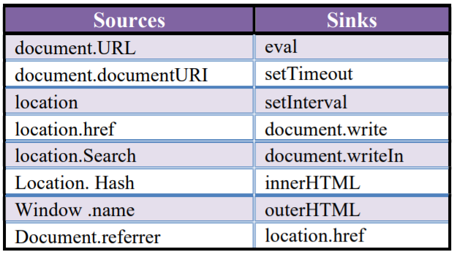
Fig 5: Some Popular Sources and Sinks.
A DOM-based XSS is a client-side injection attack because the payload injected will be executed in client-side DOM and shows response immediately without the intervention of the server. Which makes it difficult to detect by the security mechanisms at the server-side?
The Impacts of Cross-Site Scripting is
- Session Hijacking: The most popular XSS attack vectors are stealing the victim's session cookies to hijack the victim's accounts. By using which malicious user will try to impersonate victim account and access any sensitive data or features on behalf of victims.
- Stealing credentials: The attacker will use HTML pages and JavaScript to steal user or victim credentials, instead of obtaining their cookies cloning the login page and then using XSS attacker steal credentials from the user. This situation will be in favor of an attacker because the attacker will ultimately acquire plaintext credentials instead of expiring ephemeral session cookies.
- Targeting Sensitive Data
Another strong XSS attack vector is to use it to exfiltrate sensitive data or to do unauthorized activities.
  - Key logger: Using JavaScript, all keystrokes entered by a user on a vulnerable site can be logged. For this purpose, Metasploit involves an off-the-shelf payload. There are also some commercial websites offering JavaScript software that records all visitor motions, clicks, mobile gestures, or inputs in form fields that will be used for malicious reasons.
  - Port scan: XSS is also an unexpected source for port scans to be initiated against a victim's internal network by accessing a vulnerable website.

- Web site defacement:
Changing the appearance of a website vulnerable to XSS is one of the easiest and yet most efficient ways for attackers to target companies or public organizations. Either this can take organizations to the spotlight for the improper reasons by using embarrassing pictures or hacktivism messages.
Mitigations for cross-site scripting are:
The best way to mitigate the XSS is to properly sanitize the untrusted input is taken from an input field, ids, URL parameters given by user, properly escaping the special characters in input provided and also output encoding the special characters while displaying in the HTML pages, the content security headers,httponly flag, X-XSS-Protection Response Header can also be used are the features in modern is frameworks can also be to prevent XSS

File Inclusion
File inclusion vulnerability will arise due to dynamic linking or execute the files or code from the web server, and a high-risk vulnerability. in file inclusion, the application will build the path based on the user-supplied input and it can be controlled by user input. by taking this as an advantage the attacker will try to give input or inject payloads that will lead to loading confidential files from the server, deface the website, remote code execution (RCE), etc. There are two types of file inclusions.
- Local File Inclusion
Local file Inclusion is an attack targeting the input fields like id field, text boxes, text fields, URL parameters, etc that dynamically reference file and scripts from server storage and does not sanitize input fields properly, which allow an attacker to manipulate input and inject payloads with path traversal characters or to retrieve the files from the server. The local file inclusion vulnerability will further lead to directory traversal, sensitive information disclosure, and code execution or even cross-site scripting (XSS) [6].
Local file inclusion will commonly be found in PHP web applications. Based on the functionality of the application the LFI will lead to executing the input by the language parser, download the requested file or display the content of a file on the web page. The remediation of LFI is the application should accept only character and numbers for file names and should be blacklisted all the special characters, limit the access of files by the hosted application from a server through specific directories only.
- Remote File Inclusion:
In RFI malicious users will targets the web applications input fields like id parameters, text boxes, text fields, URL parameters, etc. Which dynamically reference external script that is not sanitizing the input fields properly. Using the RFI malicious users can include or load the file stored in a remote location. all kinds of web applications support the file include but most commonly it will be found in a PHP web application because, in PHP programming, we will use file includes" extensive. By using the remote file inclusion, the attacker can trick web application to load the code stored in a remote location the code will include backdoors, web shells, code execution at OS level, etc. By successfully exploiting the RFI the malicious users can gain sensitive information, take over the application or server, server hijacking, etc. The main causes of RFI are programming mistakes and misconfiguration in system settings and functionalities. The most effective way to eliminate the RFI is to completely avoid the dynamically including the files based on user inputs or keep the white list of filenames that can be included in user inputs.

Cross-Site Request Forgery
Cross-site request forgery will also be called as one-click attack or session riding, In CSRF the malicious user will try to send the forged request and makes the victim send the request that is crafted by attacker and csrf will be possible only when a user is logged in the same browser where he is submitting the request. the impact of csrf will depend on the access rights that affected user has which includes change password of victims, creating new user accounts, and can take control of application data and functionality if the user is an admin.
The CSRF will be possible in the following cases if a web application is not having any unpredictable request parameters, cookies should be used for session handling and there should be a relevant action for a request to generate the forged request, for example, password update page, new user creation pages, etc. In general, the cookies associated with the particular website will be included in the request of a browser from another domain that is stored in a browser so csrf is possible. The best mitigation for csrf is to use the random token which should be unpredictable and must be validated with every request, implementing the same-site cookie attribute to instruct the browser to include cookies to the same domain only.

Broken Authentication
It is that allows a malicious actor to get access to the user accounts by stealing the credentials or by forging the session-related data of a website. Commonly the application will implement the login functionality to give functionalities based on the user's role and will track the users based on session id. if this functionality is not implemented correctly then the malicious user will try to get access.
If the authentication mechanism has not implemented correctly then the malicious user will use the brute force technique to get credentials or if the application is using the default usernames and passwords which helps the malicious user to guess credentials very easily and he can also use Boolean based SQL injection to bypass authentication mechanisms. If the session is not managed correctly, then the malicious user can guess the session id based on earlier sessions or session hijacking or session reusing. after completing the attack by a malicious user can obtain access to user accounts which can be an admin account also.
The best methods for avoiding broken authentication related issues is to use strong password policy, account lockout policy after invalid attempts, implementing strong captcha for avoiding brute-forcing, and implementing a strong authenticating system by hashing password rather than sending in plain text. for avoiding the session management related issues is recommend not pass the session value in URLs and should be unpredictable, the values of the cookies should properly validate with every request, session should be terminated after user logged out and new has to be generated for every new login and user session should be terminated after an inactive time.

CONCLUSION
The high-level vulnerabilities like SQL injection and cross-site scripting will have a great effect on web application and these vulnerabilities will also lead to the data breach .which will leads to loss of confidentiality, integrity, availability .so to protect the web application against the breaches the vapt will play a crucial to find the potential vulnerabilities and their impact on business. The vapt will also help to find the loopholes and how to fix them. In this paper we have disused vulnerability assessment and pen testing, and vulnerabilities like SQL injection, file inclusion, cross-site scripting, etc. In a web application auditing both the manual pen testing and tools will also be used because by using tools, there will be so many false positives, will there and the vulnerabilities can be missed so manual intervention is also important and we conclude that the VAPT is the important way for identifying and eradication the security vulnerabilities in web application. In the future, we will be looking more closely for various issues related to the VAPT process such as identifying factors that impact adopting of VAPT process in business and problems in implementing security vulnerability remediation in a web application and continuing our research and study in this field.

ACKNOWLEDGMENT
I wish to express my sincere gratitude to the administration and Security Audit Team of Andhra Pradesh Technology Service Ltd, Department of Information Technology Govt. of Andhra Pradesh, KL University for providing an excellent environment and resource

 Revised Manuscript Received on March 01, 2020. * Correspondence Author Matthi Naveen*, Student, CSE, KLEF, Vaddeswaram, Guntur Dist., India, Pincode:522502, Email: matthinaveen@gmail.com Dr Pragnyaban Mishra, Assoc Professor, CSE, KLEF, Vaddeswaram, GunturDist, india-522502,Email:182034009@kluniversity.in

